**Syllabus**

**Microbiology Laboratory (MCB2010L, Section 807340)**

**(Web-Enhanced Course)**

*“The ultimate measure of a man is not where he stands in moments of comfort and convenience, but where he stands at times of challenge and controversy”*

—Dr. Martin Luther King, Jr

**Term**: Fall 2014-1

**Class** **location**: Room 1663

**Class Meeting time**: Tuesdays, 5:40PM – 9:00PM

Professor: Dr. Félix E. Rivera-Mariani

Office: Room 1663

Office Hours: Tuesday: 3:00PM – 5:00PM or by appointment

Thursday: 3:00PM – 5:00PM or by appointment

**Email**: [friveram@mdc.edu](mailto:friveram@mdc.edu)

Phone: 800-319-4380

**Required Textbook:** Leboffe, M.J. and B. E. Pierce. 2010. Microbiology Laboratory Theory & Applications. 3rd Ed. Morton Publishing Company, Inc. Englewood, CO. (ISBN 978-0-86582-830-9).

**e-book:** [**http://www.coursesmart.com/IR/7362944/9780895828309?__hdv=6.8**](http://www.coursesmart.com/IR/7362944/9780895828309?__hdv=6.8)

**Co-requisite:** Microbiology (MCB2010)

1. **Rationale of the course**

To provide a hands-on learning experience of the different approaches used in the laboratory to study and identify microorganisms based on their morphological (i.e. size, appearance) and physiological properties.

1. **Course Materials (Web-Enhanced Course)**

Course materials, including syllabus, Flipped classroom lectures, Lab worksheets, and supplemental materials, will be available at the following websites:

* + Miami-Dade Blackboard website:

[**https://mdc.blackboard.com**](https://mdc.blackboard.com)

1. **Required Materials**
   1. Sharpie fine-tip pen
   2. 10 cm ruler
   3. Long sleeve Lab coat
   4. Safety glassware
   5. Latex/nitrile gloves
   6. Masking tape
   7. Combination (**no key lock**) for the hall lockers
   8. Slide blox (available from Carolina Biological Supply company <http://www.carolina.com>)
2. **Methods of Instructions**

***Flipped classrooms***, in which digital formats of lectures and course materials will be made available to the students online prior to meeting in class.

***Pre-lab reading assignments*** will aid your preparation for the lab meeting, and in understanding the topics and methods to be covered in the lab. A series of online questions designed by the professor, and they must be answered prior to the lab meeting.

***Laboratory Exercises*** will be performed during each lab meeting, and a corresponding report must be turned in according to the syllabus schedule.

***Group work*** to facilitate the discussion of laboratory methods, and examination and interpretations of laboratory results.

1. **Academic Integrity**

Each student is expected to maintain a high level of integrity and abide by the procedure 4070 of the Miami-Dade College Student Rights and Responsibility Handbook. Any work submitted by a student in this course for academic credit will be the student's own work. For the purpose of this course, collaboration is allowed in the following instances:in-class group work, case studies discussions, or when stated by the professor. Nevertheless, each student must submit their individual work unless stated otherwise by the instructor.

As part of a collaborative and encouraging classroom, you are encouraged to study together and to discuss topics and concepts covered in class with other students. You can obtain "consulting" help from students as well as provide "consulting" help to other students. However, this allowed form of cooperation should never involve one student having possession of a copy of all or part of the work done by another student or someone else, in the form digital files or hard copy documents.

In the case that copying occur, both the student who copied work from another student and the student who contributed to this behavior will both automatically receive a zero for the corresponding assignment. Penalty for violation of this Code can include failure of the course and/or notifying the corresponding University authorities for disciplinary action.

During exams (i.e. quizzes and exams), you must do your own work. Talking or discussion is not allowed during the examinations. In addition, you cannot compare papers, copy from others, or collaborate in any way. Any form of the behaviors mentioned above will result in failure of the exam and can include notifying the corresponding University authorities for disciplinary action. **Cell phones cannot leave the classroom during exams, and must be turned off during class.**

Any form of Academic Dishonesty listed in the Miami-Dade College Student Rights and Responsibility Handbook will not be accepted during in the course.

**Attendance**

Attendance to each class sessions is essential for your learning. The Microbiology Lab course requires time and effort in order to learn and accomplish your goals in the course. In addition, **attendance will count 20 points of your final grade**. For each unexcused absence, **1 point will be deducted**; **for each unexcused tardiness, 0.5 point will be deducted.** In the event of an absence, the student will be allowed to make up work if the absence results from one of the following:

* Official campus activities (as designated by MDC)
* Family or personal emergencies (as designated by MDC)
* Medical reasons (discussed with the instructor)
* Work-related reasons (discuss with the instructor)

**There are no make-up Exams!**

**Laboratory Make-ups:** In case you miss a lab meeting, the student **can only make up the lab** during the week of the lab. It will be the student’s responsibility to make the lab in another lab session during the corresponding week. In order to be allowed to make up the lab, the student must bring a note signed by the professor in charge of your lab section before being allowed to make up a lab. **There are no exceptions**

**Late policy**

Unless arrangement have been made prior to the due date or have a valid absence excuse (as stated in the Attendance section of this syllabus), half the grade will be deducted for Lab Reports, and 20% will be deduced for the Unknown Writing Assignment (refer to the Lab Skills Evaluations section).

**Accommodations for students with disabilities**

In compliance with the Miami-Dade College and the Student Rights and Responsibility Handbook policy and equal access laws, I more than available to discuss any necessary academic accommodations that may be required for the student with disabilities. Requests for academic accommodations are to be made during the first week of the term, except for unusual circumstances, so arrangements can be made. Students are encouraged to contact the Student Services to verify their eligibility for appropriate accommodations.

**Inclusivity Statement**

Members (student, faculty, administrators) of the Miami-Dade College community represent a diversity of backgrounds and perspectives. In this course, and as a member of this community, I am a strong supporter of diversity and its benefits. Therefore, to maintain an adequate learning and diverse environment students in this course are strongly encouraged to:

* share their unique beliefs, experiences, and values
* be open to the opinions and views of others
* honor your colleagues’ uniqueness
* appreciate the unique opportunity we have to learn from each other
* value each other’s opinions and communicate in a respectful manner
* keep confidential discussions that the community has of a personal (or professional) nature
* take advantage of this opportunity to share ways in which an inclusive environment can be create in this course and across the Miami-Dade College community

**Grading Scales:**

|  |  |
| --- | --- |
| **Item** | **Points** |
| Lab Report | 100 |
| Attendance | 20 |
| Participation | 30 |
| Lab Skill Evaluations | 100 |
| Midterm Exam/Practicum | 100 |
| Final Exam/Practicum | 100 |
| **Total points** | **450** |

|  |  |  |
| --- | --- | --- |
| **Grade** | **Percentage** | **Points** |
| A | 100 – 90% | 392 |
| B | 89 – 80% | 347 |
| C | 79 – 70% | 302 |
| D | 69 – 60% | 248 |
| F | Below 60% | Below 248 |

|  |  |
| --- | --- |
|  |  |

**Lab Reports (10 points each)**

For each lab exercise, there is a lab report that must be completed and turned in. Due dates for each lab report are listed on the syllabus schedule as well as on the Blackboard website of the course. Answers must be in complete sentences and **binomial scientific names must be underlined when handwritten or italicized when word processed (*e.g. Escherichia coli*)**. If mistakes are made on the lab reports, the students must cross the mistake with a single line, initialize the crossed mistake, and write the correct answer or data. Points will be deducted for the following:

* **1 point** for not underlining binomial scientific names
* **0.5 point** for answering in incomplete sentences
* **0.5 point** for unanswered questions in the lab report
* **0.5 point** for incorrectly answering a question in the lab report
* **0.5 point** for not properly crossing a mistake on the lab report

**Lab reports can be submitted in hard copy, or as a digital file into a DropboxTM folder to be assigned for each corresponding lab report.**

**Points for Attendance (20 total points)**

As stated earlier in the syllabus, attendance counts for a grade. Points will be deducted as follows:

* **1 point** for unexcused absence
* **0.5 point** for unexcused tardiness
* **0.5 point** for leaving early the lab without notice and/or reasons (refer to the Attendance section of the syllabus)

**Participation (F*lipped Classroom and Online Guide Questions*; 30 total points)**

**Flipped Classroom** lectures, in addition to greatly contributing to your learning, will count as a grade. Therefore, the student must access the Flipped Classroom session in the MDC Blackboard LearnTM website. Each Flipped Classroom video or session will have short quizzes to help you learn the material. In addition, **online Guide Reading Questions** related to the lab exercise to be performed in the lab for that week will be sent via email, and the student must returned the answered those. The professor will received an email notification for both, when the student access the Flipped Classroom section and after the student completes the **online Guide Reading Questions** questions. Points will be deduced as follows:

* **1 point** for not accessing the Flipped Classroom session
* **0.1 point** for incorrect answers in the Flipped Classroom quizzes
* **1 point** for not answering the online Guide Questions
* **0.1 point** for incorrect answers of the online Guide Questions

**Due Dates for Flipped Classroom and Online Guide Questions will be posted on the MDC Blackboard LearnTM website.**

**Exams**

Two 100 points exams (Midterm and Final) will be administrated during regular laboratory periods. Refer to the syllabus schedule to know the dates of the exams. Each of the exams will be multiple choice questions. No scantrons are needed: questions will be answered on the printed exam provided. In case a calculator is needed for a given question, each student must bring their own calculator: **no shared calculators will be allowed and cellphones will not be allowed to be used as calculators**.

At the next lab sessions, the students will received a Scorecard of the exam and copy of the exam: **exams must be returned to the professor and cannot be photographed**. Academic Dishonesty regulations, as stated in the MDC student handbook, will be strictly enforced. Any violations will result in a zero on the exam.

**There are no make-ups for Exams.**

**Lab Skills Evaluation**

|  |  |  |
| --- | --- | --- |
|  | Lab Skill Evaluations | Points |
| I | Aseptic transfer of microbes (Exercise 1-3) | 10 |
| II | Streaking for isolation (Exercise 1-4) | 10 |
| III | Preparation of bacterial smears with Gram stain & Unknown (Exercise 3-7) | 10 |
| IV | Morphological and Physiological Unknown (Multiple Exercises) | 70 |

**Source: Dr. Edwin Guines-Candelaria**

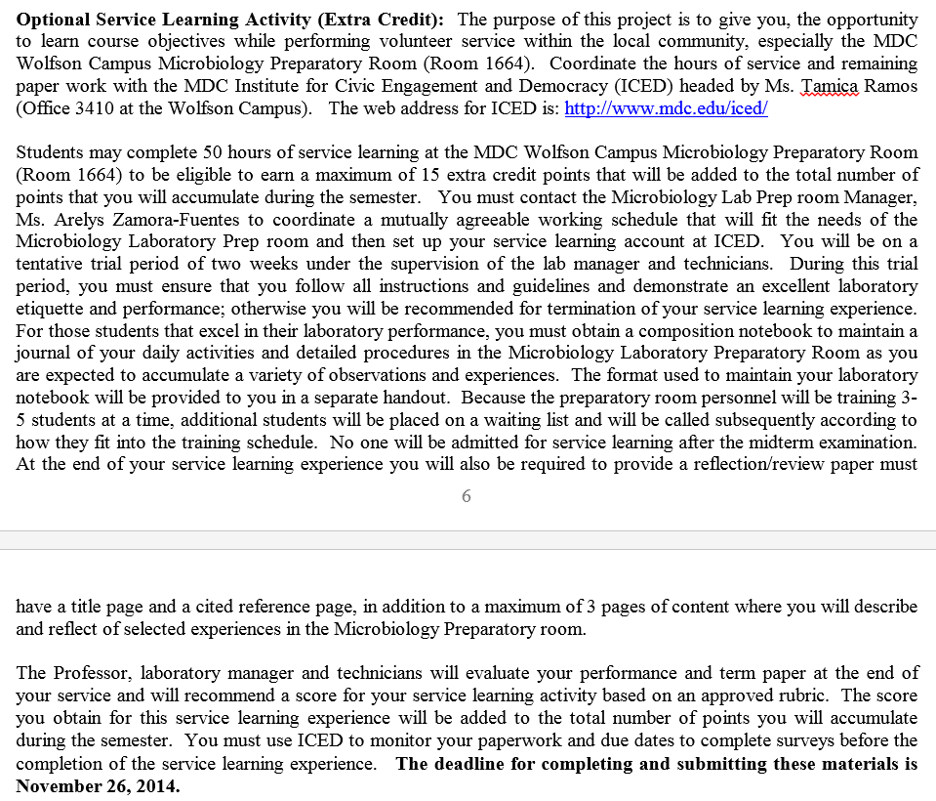

**Source: Dr. Edwin Guines-Candelaria**

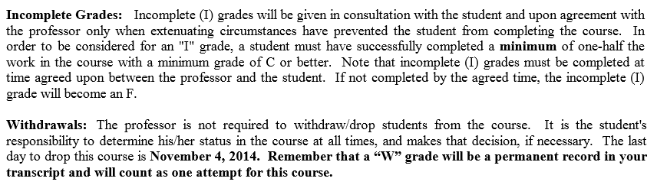

**Source: Dr. Edwin Guines-Candelaria**

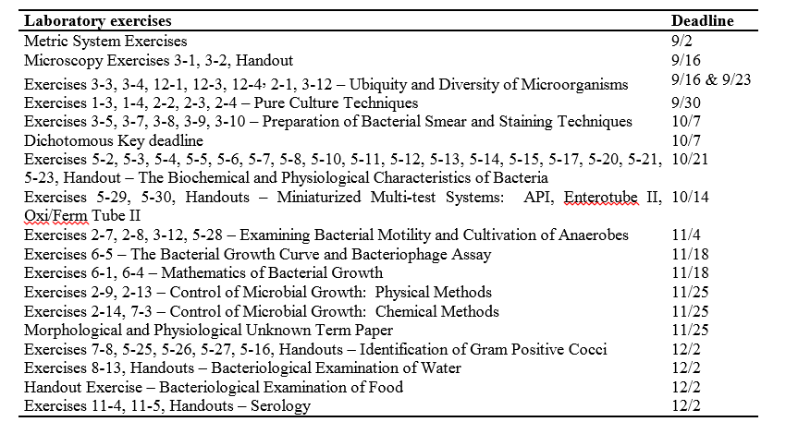

**Source: Dr. Edwin Guines-Candelaria**

**Tentative Course Schedule (schedule may change due to unexpected events)**

**(Due dates for Flipped Classroom/Online Guide Questions are posted on Blackboar LearnTM)**

|  |  |  |  |
| --- | --- | --- | --- |
| **Date** | **Week** | **Topic** | **-Lab Reports Due Dates**  **-Unknown paper Due Date** |
| Aug-26 | W1 | -Course Introduction  -Discussion of Syllabus  -Metric System |  |
| Sep-02 | W2 | -Microscopy: Bright Field Microscopy | -Metric System Lab Reports |
| Sep-09 | W3 | -Microscopy (continue)  -Ubiquity and Diversity of Microorganisms |  |
| Sep-16 | W4 | -Cultural Characteristics of Microorganisms  -Aseptic Techniques  -Pure Culture Techniques  -Preparation of a Bacterial Smear  -Simple Staining | -Microscopy Lab Reports |
| **Sep-23** | **W5** | -Differential Staining  -Gram Stain  -Kinyoun Acid-Fast Stain  -Gram Stain unknown  **-Morphological and Physiological**  **Unknown (begin and discussion)** | -Ubiquity Lab Reports |
|  |  |  |  |
| Sep-30 | W6 | -Special Staining Techniques  -Endospore Stain  -Capsule Stain  -Morphological and Physiological Unknown | -Pure Culture Techniques Lab Reports |
| **Oct-07** | **W7** | -Physiological Characteristics: Oxidation  and Fermentation  -Hydrolytic and Degradation Reactions  -Multiple Test Media  -Morphological and Physiological Unknown | -Preparation of Smear  -Staining Techniques  **-Dichotomous Key** |
|  |  |  |  |
| Oct-14 | W8 | -Physiological Characteristics (cont)  -Miniaturized Multi-test  -Morphological and Physiological Unknown |  |
| **Oct-21** | **W9** | **-Mid-Term Exam (100 points)**  -Morphological and Physiological Unknown | -Physiological Characteristics  -Miniaturized Multiple Tests |
|  |  |  |  |
| Oct-28 | W10 | **-**Cultivation of Anaerobes  -Bacterial Motility  -Morphological and Physiological Unknown |  |
|  |  |  |  |
| Nov-04 | W11 | -Enumeration of Bacteria  -Bacterial Growth Curve  -Cultivation of Anaerobes (cont)  -Morphological and Physiological Unknown | -Bacterial Motility  -Cultivation of Anaerobes |
| Nov-11 | W12 | -Effects of Temperature and UV  -Antiseptics/Disinfectants  -Kirby-Bauer Antimicrobial Test  -Isolation of Staphylococci  -Isolation of Streptococci  -Bacterial Examination of Food  -Bacterial Examination of Water  -Morphological and Physiological Unknown |  |
| Nov-18 | W13 | -Effects of Temperature and UV  -Antiseptics/Disinfectants  -Kirby-Bauer Antimicrobial Test  -Isolation of Staphylococci  -Isolation of Streptococci  -Bacterial Examination of Food  -Bacterial Examination of Water  -Morphological and Physiological Unknown | -Bacterial Growth Curve |
| **Nov-25** | **W14** | -Kirby-Bauer Antimicrobial Test  -Isolation of Staphylococci  -Isolation of Streptococci  -Bacterial Examination of Food  -Bacterial Examination of Water  **-Morphological and Physiological**  **Unknown Deadline** | -Effects of Temperature and UV  -Antiseptics/Disinfectants  -Kirby Bauer Antimicrobial Test |
| Dec-02 | W15 | -Isolation of Streptococci  -Bacterial Examination of Food  -Bacterial Examination of Water  -Isolation of Coliforms | -Identification of Staphylococci  -Identification of Staphylococci  -Bacterial Examination of Water  -Bacterial Examination of Food |
|  |  |  |  |
| Dec-09 | W16 | -Isolation of Streptococci  -Bacterial Examination of Food  -Bacterial Examination of Water  -Isolation of Coliforms  -The Enterics – Serological Reactions  -ABO blood type |  |
| Dec-16 | W17 | **-Final Exam and Practicum**  **-Lab Clean-up** |  |
|  |  |  |  |